# Study 1

**Method**

Study 1 analyzed the effects of social consensus using a within-subjects design. Participants were randomly assigned to either the low or high social consensus manipulation condition. Information about social consensus was presented for all four highly polarized issues. The primary outcome, attitude towards the highly polarized issues, was measured both before and after presentation of social consensus information. The Institutional Review Board at the University of Missouri reviewed and approved all submitted materials for Study 1.

***Participants***

A total of 505 undergraduate students 18 years of age or older at the University of Missouri participated in this study. Participants were recruited through an online survey platform and were offered psychology course credit in exchange for their participation. Participants were asked to select categories that best described their race/ethnicity. Participants self-identified as: White (77%), Black (5.3%), Hispanic (6.7%), Asian (5.1%), Native American (0.39%), ‘other’ (2.4%), or ‘prefer not to say’ (1.8%). Participants also self-selected their preferred gender identity; 63.6% participants identified as ‘Female’, 33.5% ‘Male’, 1.4% ‘Gender Variant or Nonconforming’, and 1.6% ‘prefer not to say’. They ranged in age from 18 to 39 years (*M* = 18.9, *SD* = 1.99).

***Materials and Procedure***

For each of the four highly polarized issues (Climate Change, Universal Health Care, Death Penalty, and Slavery), participants were first asked to estimate the proportion of the US population in 2018 that would be in support of the issues. Then, participants were given information about social consensus on each of these four issues. To manipulate the perception of social consensus, participants were randomized into a ‘high social consensus’ or ‘low social consensus’ condition. In both conditions, participants were given feedback consisting of the base rate of support that the general American public (in 2018) had for the four highly polarized issues. Participants in the ‘high social consensus’ condition saw results that were 20% higher than the true base rate. Participants in our ‘low social consensus’ condition saw results that were 20% lower than the true base rate. For example, if 65% of Americans agree that the Death Penalty is necessary in the US, the high social consensus condition would be told that 85% agree, and the low social consensus condition would be told that 45% agree.

After the social consensus information, participants are asked to indicate their degree of surprise at the stated level of public support and estimate levels of public levels support in 2023. Participants are then asked to identify their level of support for each of each of the four highly polarized issues. Finally, participants completed several individual difference measures and provided demographic information.

***Measures***

**Primary Outcome.** Participant support for the highly polarized issues was captured as continuous variable ranging from strong disagreement (0) to strong agreement (100) with the following statements: 1) “Greenhouse gas emissions generated by human activity has and will continue to change Earth's climate” (*Climate Change*); 2) “The US government needs to implement Universal Health Care because basic population needs are not being met.” (*Universal Healthcare*); 3) “Capital Punishment (the Death Penalty) is necessary in the US” (*Death Penalty*), and 4) “Slavery, forced labor, and human trafficking are violations of human rights.” (*Slavery*).

Secondary Outcomes. Estimates of public support for the four highly polarized issues were obtained by asking participants to estimate what percentage of the American public would agree with the above statements. Participants provided a number ranging from 0-100%. Separate estimates were obtained for 2018 and 2023. Participants were also asked to rate how ‘surprised’ they were at the 2018 social consensus information provided. Surprise was measured with a 5-point Likert scale ranging from ‘Not Surprised’ (1) to ‘Very Surprised’ (5).

Individual differences in deontological and utilitarian orientation were measured using the Ethical Standards of Judgement Questionnaire (ESJQ) developed by Love, Salinas, and Rotman (2020). Six items measure deontological orientation (e.g., “Solutions to ethical problems are usually black and white”), and six items measure utilitarian orientation (e.g., “When people disagree over ethical matters, I strive for workable compromises”). Participant agreement with these statements was measured with 5-point Likert scales ranging from ‘Strongly Disagree’ (1) to ‘Strongly Agree’ (5). Each six-item subscale showed satisfactory internal consistencies with Cronbach’s α of .783 (deontology) and .750 (utilitarianism).

Health literacy was measured using the Single Item Health Literacy Screener (SILS) developed by Morris, MacLean, Chew, and Littenberg (2006). Health literacy is measured by self-reported confidence with medical forms (e.g., “How confident are you filling out medical forms by yourself?”) using a 5-point Likert scale ranging from ‘Never’ (1) to ‘Always’ (5). We used two separate measures of numeracy. The Subjective Numeracy Scale (SNS) developed by Zikmund-Fisher, Smith, Ubel, and Fagerlin (2007) contains four items that measure cognitive abilities, e.g., “How good are you at working with fractions”), rated with 5-point Likert scales ranging from ‘Not at all good’ (1) to ‘Extremely good’ (5). An additional four items measure preference for numeric information, e.g., “When reading the newspaper, how helpful do you find tables and graphs that are parts of a story?”), rated with 5-point Likert scales such as ‘Not at all helpful’ (1) to ‘Extremely helpful’ (5). Objective numeracy was measured using a number line estimation task adapted from Sigler, Thompson, and Schneider (2011). This task consisted of placing fractions in the correct place on a number line. Participant placed 10 fractions on a number line that ranged 0-1 (e.g., 1/19, 1/7, 3/8, 11/14), and 10 fractions on a number line that ranged from 0-5 (e.g., 17/4, 9/2) Performance was calculated as the total percent absolute error accumulated across all fractions, defined as: (|Answer - Correct Answer|) / Numerical Range.

***Power and Statistical Analysis***

A minimum sample of 158 participants was needed to achieve 95% power for a linear multiple regression with the following parameters: ANOVA, repeated measures, between factors, an effect size of .25, an alpha of .05, two groups, two measurements, and .5 correlation among repeated measures. Power was determined a-priori using G-power 3.1.9.7 (Faul, Erdfelder, Lang, and Buchner, 2007; Faul, Erdfelder, Buchner, and Lang, 2009). The four highly polarized beliefs that were surveyed were all treated as continuous variables. We examined the effects of experimental condition (high or low social consensus) and individual differences (deontological and utilitarian orientation, health literacy, multiple measures of numeracy) on our outcome measure. We examined the main effect, as well as interactions between deontology and utilitarianism with our experimental conditions for our predictors. All tests were conducted in R and considered statistically significant when P <.05.

***Study 1 Hypotheses***

We predicted high social consensus would lead to more positive support for highly polarized issues (H1). Additionally, our second hypothesis is that the two subscales, Utilitarian and Deontological Orientation, of the ethical standards of judgement questionnaire (ESJQ) would be significant predictors of support for these polarized issues. (e.g., our hypothesis had no *a-priori­* directional effect).

**Results**

We tested our two hypotheses with a series of within-subjects analysis of variance (ANOVA) models comparing support for the highly polarized issues both before and after our social consensus manipulation. The alpha level for these analyses was .05.

***Social Consensus Manipulation***

Each of our four ANOVA models was composed of our dependent variable (quantified as level of support for our issues), with time, condition, numeracy (subjective and objective), utilitarian orientation, deontological orientation, and health literacy as our ‘simple effect’ predictors. To test H1, we conducted a mixed ANOVA with time (pre or post intervention) as a within-subjects factor and our social consensus manipulation (high or low social consensus condition) as a between-subjects factor.

In support of H1, there was a significant time x condition interaction, such that there was greater increase over time in support for the highly polarized issues in the high social consensus condition compared to the low social consensus condition. Our planned analysis revealed that participants in our two social consensus conditions had a statistically significant difference in pattern from pre- to post-intervention (e.g., participants in the high social consensus condition had higher post-intervention scores, and participants in the low social consensus had lower post-intervention scores). This pattern was the case for: 1) Universal Health Care, (ßtime x condition = 7.600, *p* = 0.015), Capital Punishment, (ßtime x condition = 8.238, *p* = *0.025*); and 3) Climate Change, (ßtime x condition = 5.614, *p* = 0.025). The table below briefly summarizes group mean differences between the conditions and times. Additionally, see figure ___ below, illustrating this pattern of effects from pre- to post- intervention.

|  |  |  |  |  |
| --- | --- | --- | --- | --- |
|  | | **IV 2: Social Consensus Condition** | | |
| High Social Consensus | Low Social Consensus |
| **IV 1: Time** | Pre-Manipulation | UHC, M(SD) = 68.90 (25.24); Death Penalty, M(SD) = 40.94 (30.14); Climate Change; M(SD) = 76.01 (22.82) | UHC, M(SD) = 67.43 (26.74); Death Penalty, M(SD) = 40.60 (28.91); Climate Change; M(SD) = 77.81 (20.28) |
| Post-Manipulation | UHC, M(SD) = 72.96 (24.30); Death Penalty, M(SD) = 45.40 (32.12); Climate Change; M(SD) = 78.65 (21.45) | UHC, M(SD) = 64.90 (27.18); Death Penalty, M(SD) = 36.84 (28.72); Climate Change; M(SD) = 74.83 (22.93) |

***Deontological and Utilitarian Orientation***

There was mixed support of H2a. Deontological orientation was a significant predictor of support for Universal Health Care (ß = 3.504, *p* < .05), where greater deontological orientation was associated with greater support for UHC but not for Capital Punishment (ß = 1.28, *p* = *NS*) or Climate Change (ß = 1.03, *p* = *NS*). Furthermore, there was no support for H2b; utilitarian orientation was not a significant predictor of Universal Health Care (ß = -0.470, *p* = *NS*), Capital Punishment (ß = -1.00, *p* = *NS*), or Climate Change (ß = 1.256, *p* = *NS*).

***Exploratory Analyses***

In addition to our planned analyses, we conducted additional exploratory analyses on the effects of the individual differences on our main outcome measure of support for a given highly polarized belief. Individual differences in objective numeracy had no significant effects on support for: 1) Universal Health Care, (ß = -0.103, *p* = *NS*); 2) Capital Punishment, (ß = 0.390, *p* = *NS*); or 3) Climate Change, (ß = 0.335, *p* = *NS*). Additionally, individual difference in subjective numeracy had no significant effects on support for: 1) Universal Health Care, (ß = 0.558, *p* = *NS*); 2) Capital Punishment, (ß = 0.431, *p* = *NS*); or 3) Climate Change, (ß = -0.339, *p* = *NS*). Likewise, individual differences in health literacy had no significant effects on support for: 1) Universal Health Care, (ß = 0.313, *p* = *NS*); 2) Capital Punishment, (ß = -0.620, *p* = *NS*); and 3) Climate Change, (ß = -0.147, *p* = *NS*). These results indicate that individual differences in objective/subjective numeracy and health literacy were not associated with our primary outcomes.

***Discussion***

The results for Study 1 provide evidence of two main points. First, as prior literature on the effect of social conformity suggests, perception of social consensus (whether in support or opposition of a position) results in subjects aligning themselves with that consensus. Second, that greater deontological, but not utilitarian, predisposition, can be associated with changes in support for a topic. To the extent that deontological orientation affected support for a topic, it was associated with support for Universal Health Care. Methodologically speaking, one major area of concern that was not addressed in this study was alternative methods for manipulation of support for a given topic. While manipulation of social consensus was effective, there are real concerns about the ethics of presenting a ‘false consensus’ in the process of informing and shaping public opinion. In practice, several other axis of behavior exist that have potential to be leveraged to change public support for contemporary topics. Many extremely polarizing topics are felt with ‘moral conviction’, thus, it seems to be a plausible direction to manipulate perspective change. Finally, all four of our topics for Study 1 were chosen due to prior literature indicating the topic as highly polarized (climate change, capital punishment, death penalty) or because there is plausible reason to believe ethical concerns would affect the issue (Universal Health Care). However, we have not looked at how manipulations that can lead to perspective change could be different in the context of a ‘non-polarized’ topic. Therefore, we planned to incorporate an intentionally ‘non-polarized’ topic for our next study. With these issues in mind (manipulating a different axis of behavior for perspective change, choosing a non-polarized topic), Study 2 was initiated.

# Study 2

**Method**

Study 2 analyzed the effects of moral conviction manipulation on cultural topics using a between-subjects design. Participants were randomly assigned to either one of four moral conviction manipulations: 1) Moral Reponsibility 2) Moral Piggybacking, 3) Pragmatic, 4) Hedonic, or a control condition. Each of the experimental conditions framed the benefits of a given perspective using either objective moral value, personal economic value, or personal enjoyment value. The primary outcome, support for a given topic, was measured after presentation of the moral conviction manipulation. The Institutional Review Board at the University of Missouri reviewed and approved all submitted materials for Study 2.

***Participants***

A total of 208 undergraduate students 18 years of age or older at the University of Missouri participated in this study. Participants were recruited through an online survey platform and were offered psychology course credit in exchange for their participation. For this pilot study, we did not collect any demographic information.

***Materials and Procedure***

For each of our four issues (UHC, Climate Change, Capital Punishment, and Exercise), participants in our experimental conditions were asked to read a short essay and then respond to a series of survey questions; Participants in our control condition were not asked to read any essay, and instead were directly provided the survey questions. The four topics selected were designed to vary in the baseline level of attitude strength and polarization; climate change and capital punishment are known to be issues that society views with significant attitude strength and polarization, exercise is seen as an issue with weak attitude strength that is non-polarized, and UHC was chosen as an issue that plausibly has polarization, but has not been explicitly examined through that lens in prior literature. To manipulate the perception of moral conviction, participants were randomly assigned to receive one of five conditions: 1) control, 2) moral responsibility, 3) moral piggybacking, 4) pragmatic, 5) hedonic; See Appendix X for the text of all five conditions. Thus, each participant in our experimental condition would be provided four essays, one for each topic, that all share the same moral framing.

Participants in the ‘moral responsibility’ condition were given essays that consisted of language emphasizing moral concepts such as ‘obligation’ or ‘responsibility’ and explicitly emphasizing moral costs and benefits. Participants in the ‘moral piggybacking’ condition were given essays that directly linked the topic to another commonly understood moral concept, such as ‘freedom of speech’, ‘justice for all’, or the ‘inherent value of human life’. Participants in the ‘pragmatic’ condition were given essays that directly highlighted the personal economic and rational benefits, such as reduced taxes, increased income, or increased health. Participants in the ‘hedonic’ condition were given essays that emphasized personal enjoyment or pleasure-based benefits such as ‘improved mood and health’ or ‘visiting a beautiful beach’. All essays were readable at a high school level, as assessed by a Flesh-Kincaid readability score. Additionally, essays within categories had comparable word counts.

***Measures***

**Primary outcome.** Moral conviction was assessed using eight items which were selected from prior work on the topic, scored as an average. The first three elements of the measure reflect a ‘lay understanding’ of moral conviction, that assesses not just a person’s personal attitude about a topic, but their perception of moral conviction for that topic in general (e.g., [topic] could be described as a moral issue). The last five elements of the measure assess whether or not the individual themselves sees their stance on an issue as based on morality (e.g., My attitude about [topic] is a reflection of my core moral beliefs and convictions). All items were captured as continuous variables ranging from strong disagreement (-50) to strong agreement (50). In addition, participant support levels for each issue were captured using similar methods to Study 1, except support was scored from strong disagreement (-50) to strong agreement (50) with the following statements: 1) “Greenhouse gas emissions generated by human activity has and will continue to change Earth's climate” (*Climate Change*); 2) “The US government needs to implement Universal Health Care because basic population needs are not being met.” (*Universal Healthcare*); 3) “Capital Punishment (the Death Penalty) is necessary in the US” (*Death Penalty*), and 4) “Regular exercise is necessary for Americans.” (*Exercise*).

Secondary Outcomes. Openness to belief change on each issue was assessed with single item direct measure (e.g., How open are you to changing your mind about [issue]). Participant agreement with this statement was measured on a continuous scale ranging from extremely unlikely (-50), to extremely likely (50). Participant’s perception of essay persuasiveness was assessed likewise assessed with a single item direct measure (e.g., How persuasive was the above essay on your beliefs regarding [highly polarized issue]). Agreement with this statement was measured on a continuous scale ranging from extremely unpersuasive (-50), to extremely persuasive (50).

***Power and Statistical Analysis***

A sample size of 157 was determined using G-power 3.1.9.7 with the following parameters: ANCOVA – an effect size of .35, an alpha of .05, and a power of .95. Support for the four beliefs that were surveyed (climate change, death penalty, support for UHC, exercise) was treated as a continuous variable. We examined the effects of experimental condition (four moral conviction intervention conditions and a control) on our outcome measures. We examined the main effect. All tests were conducted in R and considered statistically significant when P <.05.

***Study 2 Hypothesis:***

Our first hypothesis (H1) predicted that the moral conviction manipulation would be a significant predictor of support for our four topics (e.g., our hypothesis had no *a-priori­* directional effect), as compared to the control condition. Additionally, our second hypothesis (H2) is that the moral piggybacking and moral responsibility interventions would increase moral conviction relative to the control, and that the pragmatic and hedonic interventions would decrease moral conviction relative to the control.

**Results**

We tested both hypothesis with an ANCOVA model comparing our outcome measure (support or level of moral conviction for [topic]) after our moral conviction manipulation. Significant differences will be explored further with Tukey’s HSD test. The alpha level for these analyses was .05.

***Moral Conviction Manipulation – Support for [Topic]***

Each of our four ANCOVA models was composed of our dependent variable (quantified as level of support for our issues), with condition and openness to belief change as our ‘simple effect’ predictors. We also plan on examining the interaction of ‘condition’ and ‘openness to belief change’ to test the homogeneity of variance assumption. To test H1, we conducted an ANCOVA model with our moral conviction manipulation as a between-subjects factor.

There was mixed support for H1, as our moral conviction manipulation had no main effect on support for: 1) Universal Health Care, (*F* (4, 198) = 0.235, *p* = *NS*); 2) Capital Punishment, (*F* (4, 201) = 0.901, *p* = *NS*); 3) Climate Change, (*F* (4, 199) = 0.364, *p* = *NS*); or 4) Exercise, (*F* (4, 200) = 1.442, *p* = *NS*). However, there was a significant main effect of openness to belief change on support for UHC (*F* (1, 198) = 6.825, *p* < .001) and exercise (*F* (1, 200) = 2.819, *p* < .01). Further examination indicated that the homogeneity of variance assumption was violated, as the ‘experimental condition’ x ‘openness to belief change’ interaction was significant for the topic of UHC (*F* (4, 198) = 3.924, *p* < .01). Given that this assumption was violated, we re-examined this data with a multiple regression model instead, predicting support for our topic with the predictors of experimental condition, ‘openness to belief change’, and their interaction. For the topic of UHC, we found a significant main effect of openness to belief change (ßbelief change = 0.3919, *p* < .01) and the pragmatic condition (ßpragmatic = 11.816, *p* < .05), as well as significant interactions between openness to belief change and the pragmatic conditions (ßbelief change x pragmatic = -0.5181, *p* < .01).

***Moral Conviction Manipulation – Level of Moral Conviction Regarding [Topic]***

Each of our four ANCOVA models was composed of our dependent variable (quantified as level of moral conviction regarding [topic]), with condition and openness to belief change as our ‘simple effect’ predictors. We also plan on examining the interaction of ‘condition’ and ‘openness to belief change’ to test the homogeneity of variance assumption. To test H2, we conducted an ANCOVA model with our moral conviction manipulation as a between-subjects factor.

There was no support for H2, as our moral conviction manipulation had no main effect on moral conviction felt for: 1) Universal Health Care, (*F* (4, 146) = 0.456, *p* = *NS*); 2) Capital Punishment, (*F* (4, 146) = 0.345, *p* = *NS*); 3) Climate Change, (*F* (4, 146) = 0.941, *p* = *NS*); or 4) Exercise, (*F* (4, 146) = 0.248, *p* = *NS*). Experimental conditions resulted in no differences in level of moral conviction regardless of the topic. However, there was a significant effect of openness to belief change on moral conviction for: 1) Climate Change (*F* (1, 199) = 5.276, *p* < 0.05) and 2) Capital Punishment (*F* (1, 201) = 4.847, *p* < .05), such that greater openness to belief change predicted greater perceived moral conviction.

***Exploratory Analyses***

In addition to our planned analyses, we conducted additional exploratory analyses on baseline differences in moral conviction and openness to belief change by topic. We used a simple one-way ANOVA predicting moral conviction or openness to belief change, with topic (e.g., UHC, Climate Change, etc.) as our main predictor. Our first one-way ANOVA revealed that there was a statistically significant difference in openness to belief change between at least two of our topics (*F* (3, 822) = 6.443, *p* < .001). A post hoc Tukey test showed that topic of UHC had significantly greater openness to belief change at p < .05; there were no significant differences between any of the other topics on openness to belief change.

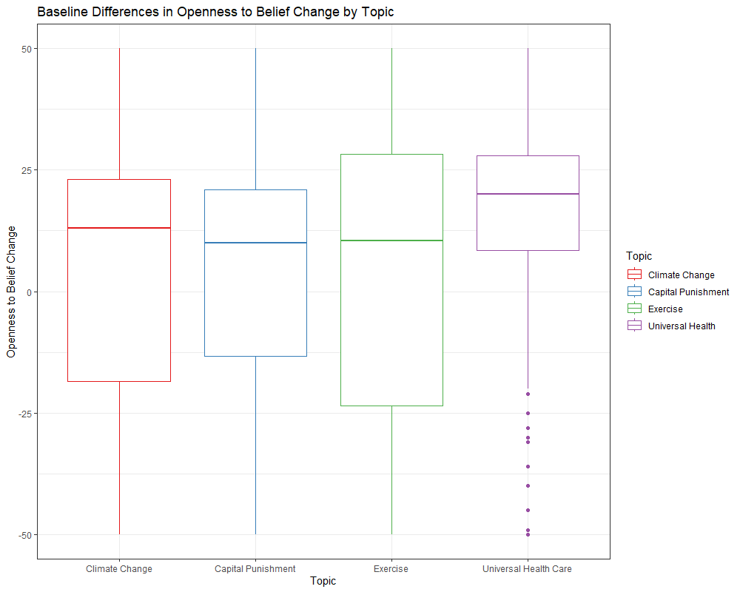

Our Second one-way ANOVA revealed that there was a statistically significant difference in level of moral conviction between at least two of our topics (*F* (3, 822) = 67.33, *p* < .001). A post hoc Tukey test showed that topic of exercise had significantly lower levels of moral conviction at p < .05; there were no significant differences between any of the other topics on moral conviction.

